**ASSIGNMENT 1 FRONT SHEET**

|  |  |  |  |
| --- | --- | --- | --- |
| **Qualification** | **BTEC Level 5 HND Diploma in Computing** | | |
| **Unit number and title** | Unit 16: Cloud computing | | |
| **Submission date** |  | **Date Received 1st submission** |  |
| **Re-submission Date** |  | **Date Received 2nd submission** |  |
| **Student Name** |  | **Student ID** |  |
| **Class** |  | **Assessor name** |  |
| **Student declaration**  I certify that the assignment submission is entirely my own work and I fully understand the consequences of plagiarism. I understand that making a false declaration is a form of malpractice. | | | |
|  |  | **Student’s signature** |  |

**Grading grid**

|  |  |  |  |  |  |  |
| --- | --- | --- | --- | --- | --- | --- |
| P1 | P2 | P3 | P4 | M1 | M2 | D1 |
|  |  |  |  |  |  |  |

|  |  |  |
| --- | --- | --- |
| **❒ Summative Feedback: ❒ Resubmission Feedback:** | | |
| **Grade:** | **Assessor Signature:** | **Date:** |
| **Internal Verifier’s Comments:** | | |
| **Signature & Date:** | | |

**ASSIGNMENT 1 BRIEF**

|  |  |  |  |
| --- | --- | --- | --- |
| **Qualification** | **BTEC Level 5 HND Diploma in Computing** | | |
| **Unit number** | Unit 16: Cloud computing | | |
| **Assignment title** | Cloud Computing Solutions | | |
| **Academic Year** | 2021 – 2022 | | |
| **Unit Tutor** | DO Quoc Binh | | |
| **Issue date** |  | **Submission date** |  |
| **IV name and date** |  | | |

|  |
| --- |
| **Submission Format:** |
| *Format:* The submission is in the form of 1 document  You must use font *Calibri size 12, set number of the pages and use multiple line spacing at 1.3. Margins must be: left: 1.25 cm; right: 1 cm; top: 1 cm and bottom: 1 cm.* The reference follows Harvard referencing system.  *Submission* Students are compulsory to submit the assignment in due date and in a way requested by the Tutors. The form of submission will be a soft copy posted on <http://cms.greenwich.edu.vn/>  *Note:* The Assignment *must* be your own work, and not copied by or from another student or from  books etc. If you use ideas, quotes or data (such as diagrams) from books, journals or other sources, you must reference your sources, using the Harvard style. Make sure that you know how to reference properly, and that understand the guidelines on plagiarism. *If you do not, you definitely get failed* |
| **Unit Learning Outcomes:** |
| **LO1** Demonstrate an understanding of the fundamentals of Cloud Computing and its architectures.  **LO2** Evaluate the deployment models, service models and technological drivers of Cloud Computing and validate their use. |
| **Assignment Brief and Guidance:** |
| Scenario  ATN is a Vietnamese company which is selling toys to teenagers in many provinces all over Vietnam. The company has the revenue over 700.000 dollars/year. Currently each shop has its own database to store transactions for that shop only. Each shop has to send the sale data to the board director monthly and the board director need lots of time to summarize the data collected from all the shops. Besides the board can’t see the stock information update in real time.  The table of contents in your technical report should be as follows:   1. As a developer, explain to the board director the fundamentals of cloud computing and how it is popular nowadays(about 2500 words) 2. Proposed solution (higher level solution description – around 700 words) and explain the appropriateness of the solution for the scenario (about 400 words with images and diagrams)which might include:    1. Architectural design (architectural diagram and description).    2. Detailed design:       1. Deployment model (discussion on why that model was chosen).       2. Service model (discussion on why that model was chosen).       3. Programming language/ webserver/database server chosen. 3. Summary.   General guidelines:   * Instead of providing definitions but also provide with examples. * Provide more own arguments instead of definitions * Making use of academic references instead of web tutorials * For a cloud architecture look at the bottom of this document |

|  |  |  |
| --- | --- | --- |
| Learning Outcomes and Assessment Criteria | | |
| Pass | Merit | Distinction |
| **LO1** Demonstrate an understanding of the fundamentals of Cloud Computing and its architectures | | **LO1 & 2**  **D1** Justify the tools chosen to realise a Cloud Computing solution. |
| **P1** Analyse the evolution and fundamental concepts of Cloud Computing.  **P2** Design an appropriate architectural Cloud Computing framework for a given scenario. | **M1** Discuss why an organisation should migrate to a Cloud Computing solution. |
| **LO2** Evaluate the deployment models, service models and technological drivers of Cloud Computing and validate their use | |
| **P3** Define an appropriate deployment model for a given scenario.  **P4** Compare the service models for choosing an adequate model for a given scenario. | **M2** Demonstrate these deployment models with real world examples. |

A cloud architecture example:

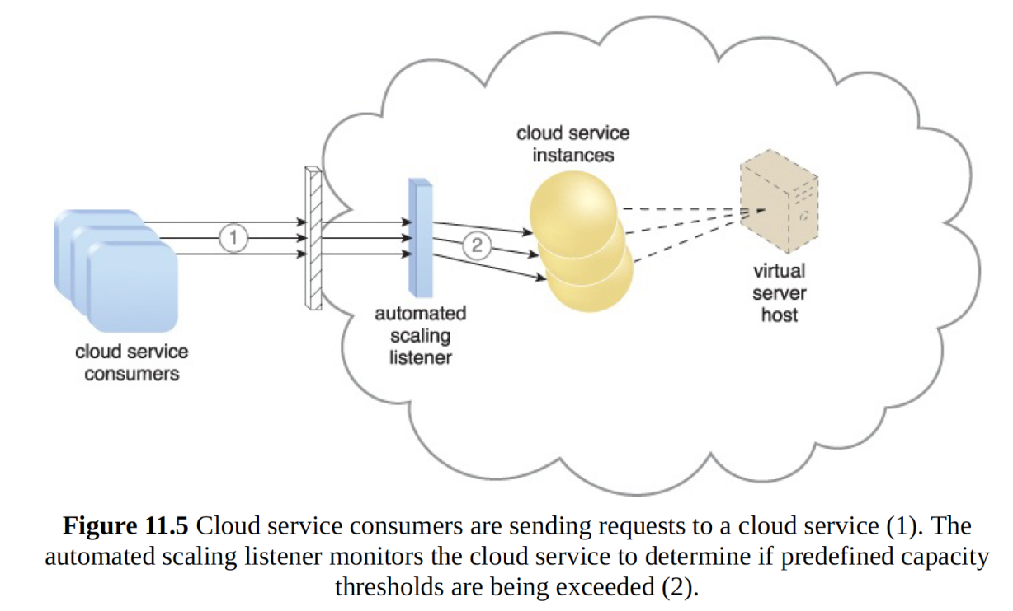

The dynamic scalability architecture can be applied to a range of IT resources, including

virtual servers and cloud storage devices. Besides the core automated scaling listener and

resource replication mechanisms, the following mechanisms can also be used in this form

of cloud architecture:

• Cloud Usage Monitor – Specialized cloud usage monitors can track runtime usage

in response to dynamic fluctuations caused by this architecture.

• Hypervisor – The hypervisor is invoked by a dynamic scalability system to create or

remove virtual server instances, or to be scaled itself.

• Pay-Per-Use Monitor – The pay-per-use monitor is engaged to collect usage cost

information in response to the scaling of IT resources.